Update Timesheets and Pay Statements After Initial Sync
- In Payroll Prep, Re-Open Payroll

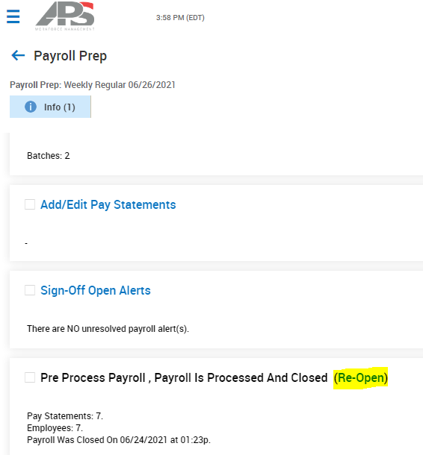

- In Payroll Prep, click on Go To Time Prep

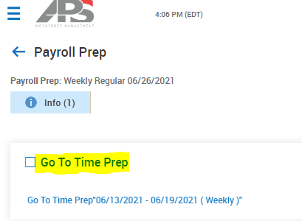

- In Time Prep, Unlock Pay Period

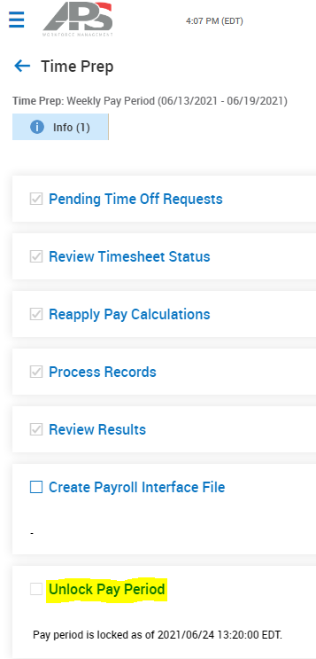
- Check the box next to “Include Unlocking Of All Accounts Within Pay Period” to unlock all timesheets in the time-period

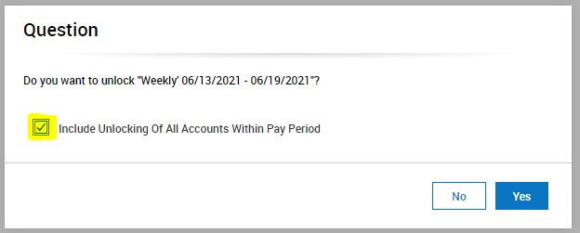

- Navigate to timesheets in pay period. For example: Team > Time > Timesheets > By Pay Period and make sure filter is showing the correct pay period.

- Click pencil icon next to timesheet you want to edit.

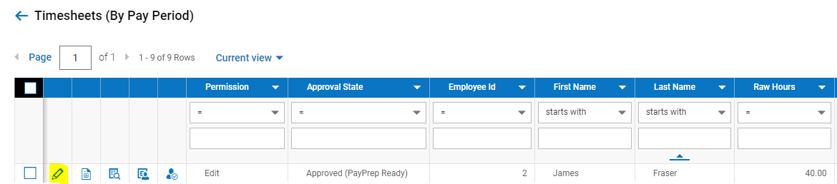

- Edit timesheet by adding time, removing time, or adding time off designation (amongst others). Click Save and check Counters to confirm changes.

- Click back-arrow to get back to other timesheets.

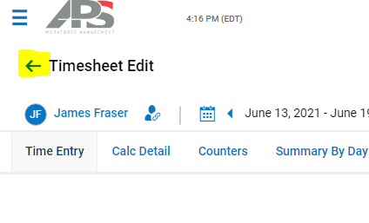

- Make remaining changes to other timesheets, if necessary, then navigate back to payroll once done.

- In Payroll Prep, Go To Time Prep

- In Time Prep, run through each step again to process updates to timesheets:

*Reapply Pay Calculations
*Process Records
*Lock Pay Period

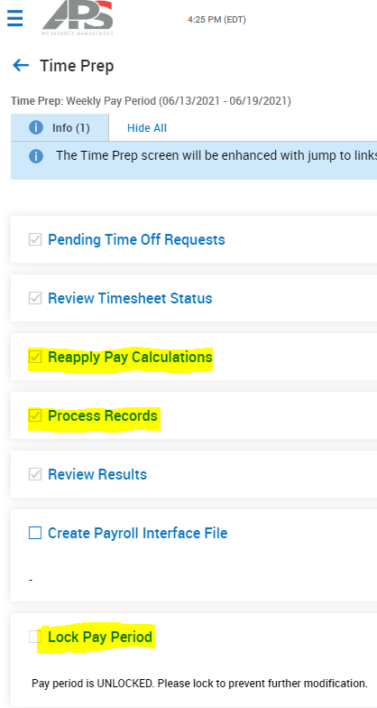

- In Payroll Prep, Sync Time (no need to Initiate Payroll again since you did it the first time you did your time prep and sync process)

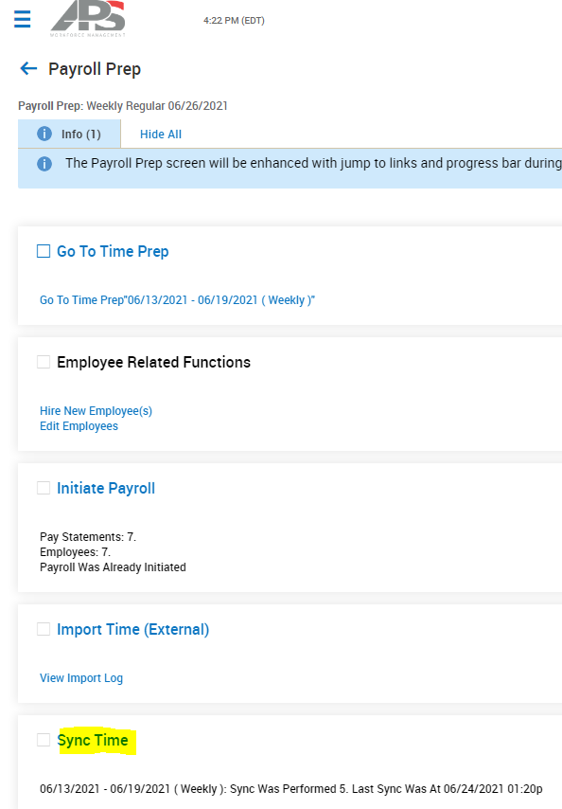
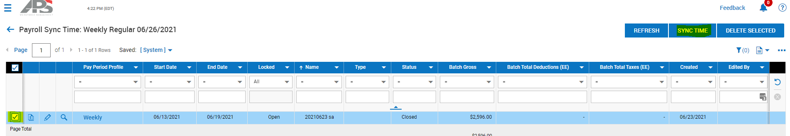

- Check your payroll again to confirm the changes. You can check the pay statements by using Add/Edit Pay Statements. You can use the Employees Not Paid report and the Payroll Register (By PST) report amongst many others.

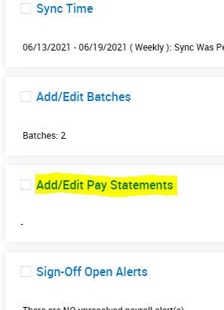
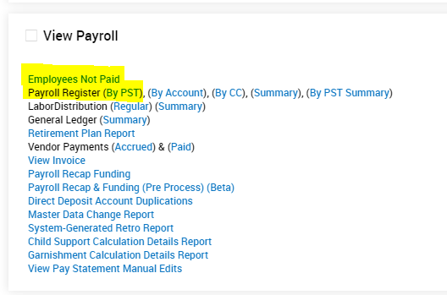

- If everything looks correct, you can finish your payroll process as you typically do.

